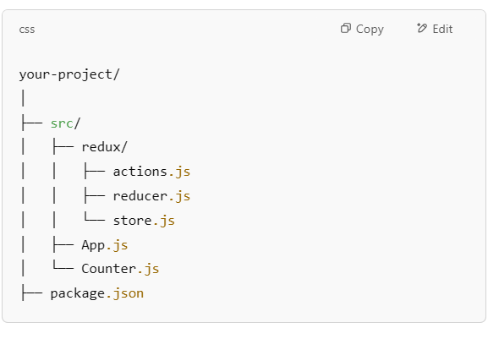

npm install redux react-redux

src/redux/actions.js

export const increment = () => {

return {

type: 'INCREMENT'

};

};

export const decrement = () => {

return {

type: 'DECREMENT'

};

};

src/redux/reducer.js

const initialState = {

count: 0

};

const counterReducer = (state = initialState, action) => {

switch (action.type) {

case 'INCREMENT':

return { count: state.count + 1 };

case 'DECREMENT':

return { count: state.count - 1 };

default:

return state;

}

};

export default counterReducer;

**src/redux/store.js**

**import { createStore } from 'redux';**

**import counterReducer from './reducer';**

**const store = createStore(counterReducer);**

**export default store;**

**src/Counter.js**

**import React from 'react';**

**import { useSelector, useDispatch } from 'react-redux';**

**import { increment, decrement } from './redux/actions';**

**function Counter() {**

**const count = useSelector(state => state.count);**

**const dispatch = useDispatch();**

**return (**

**<div style={{ textAlign: 'center' }}>**

**<h1>Counter: {count}</h1>**

**<button onClick={() => dispatch(increment())}>Increment</button>**

**<button onClick={() => dispatch(decrement())}>Decrement</button>**

**</div>**

**);**

**}**

**export default Counter;**

**src/App.js**

**import React from 'react';**

**import { Provider } from 'react-redux';**

**import store from './redux/store';**

**import Counter from './Counter';**

**function App() {**

**return (**

**<Provider store={store}>**

**<Counter />**

**</Provider>**

**);**

**}**

**export default App;**

**second** 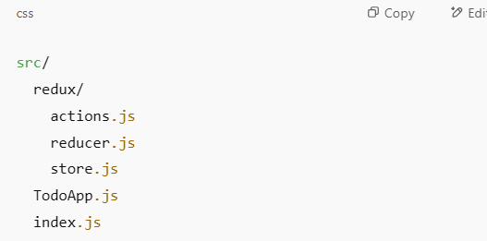

**src/redux/actions.js**

**// Action types**

**export const ADD_TODO = 'ADD_TODO';**

**export const TOGGLE_TODO = 'TOGGLE_TODO';**

**export const REMOVE_TODO = 'REMOVE_TODO';**

**// Action creators**

**export const addTodo = (text) => ({**

**type: ADD_TODO,**

**payload: text,**

**});**

**export const toggleTodo = (id) => ({**

**type: TOGGLE_TODO,**

**payload: id,**

**});**

**export const removeTodo = (id) => ({**

**type: REMOVE_TODO,**

**payload: id,**

**});**

**src/redux/reducer.js**

**import { ADD_TODO, TOGGLE_TODO, REMOVE_TODO } from './actions';**

**const initialState = {**

**todos: [],**

**};**

**let nextTodoId = 1; // For unique IDs**

**const todoReducer = (state = initialState, action) => {**

**switch (action.type) {**

**case ADD_TODO:**

**return {**

**...state,**

**todos: [**

**...state.todos,**

**{ id: nextTodoId++, text: action.payload, completed: false },**

**],**

**};**

**case TOGGLE_TODO:**

**return {**

**...state,**

**todos: state.todos.map(todo =>**

**todo.id === action.payload**

**? { ...todo, completed: !todo.completed }**

**: todo**

**),**

**};**

**case REMOVE_TODO:**

**return {**

**...state,**

**todos: state.todos.filter(todo => todo.id !== action.payload),**

**};**

**default:**

**return state;**

**}**

**};**

**export default todoReducer;**

**src/redux/store.js**

**import { createStore } from 'redux';**

**import todoReducer from './reducer';**

**const store = createStore(**

**todoReducer,**

**window.__REDUX_DEVTOOLS_EXTENSION__ && window.__REDUX_DEVTOOLS_EXTENSION__()**

**);**

**export default store;**

**Step 2: React component src/TodoApp.js**

**import React, { useState } from 'react';**

**import { useSelector, useDispatch } from 'react-redux';**

**import { addTodo, toggleTodo, removeTodo } from './redux/actions';**

**const TodoApp = () => {**

**const [input, setInput] = useState('');**

**const todos = useSelector(state => state.todos);**

**const dispatch = useDispatch();**

**const handleAdd = () => {**

**if (input.trim() === '') return;**

**dispatch(addTodo(input));**

**setInput('');**

**};**

**return (**

**<div style={{ padding: 20, maxWidth: 400, margin: 'auto' }}>**

**<h2>Redux Todo List</h2>**

**<input**

**type="text"**

**value={input}**

**onChange={e => setInput(e.target.value)}**

**placeholder="Add todo"**

**style={{ width: '70%', padding: 8 }}**

**/>**

**<button onClick={handleAdd} style={{ padding: 8, marginLeft: 8 }}>**

**Add**

**</button>**

**<ul style={{ listStyle: 'none', padding: 0 }}>**

**{todos.map(todo => (**

**<li**

**key={todo.id}**

**style={{**

**margin: '10px 0',**

**textDecoration: todo.completed ? 'line-through' : 'none',**

**cursor: 'pointer',**

**display: 'flex',**

**justifyContent: 'space-between',**

**alignItems: 'center',**

**background: '#f0f0f0',**

**padding: 8,**

**borderRadius: 4,**

**}}**

**>**

**<span onClick={() => dispatch(toggleTodo(todo.id))}>**

**{todo.text}**

**</span>**

**<button**

**onClick={() => dispatch(removeTodo(todo.id))}**

**style={{ marginLeft: 10 }}**

**>**

**Remove**

**</button>**

**</li>**

**))}**

**</ul>**

**</div>**

**);**

**};**

**export default TodoApp;**

**Step 3: Modify src/index.js to connect Redux store to React app**

**import React from 'react';**

**import ReactDOM from 'react-dom/client';**

**import { Provider } from 'react-redux';**

**import store from './redux/store';**

**import TodoApp from './TodoApp';**

**const root = ReactDOM.createRoot(document.getElementById('root'));**

**root.render(**

**<Provider store={store}>**

**<TodoApp />**

**</Provider>**

**);**